- Create the React App
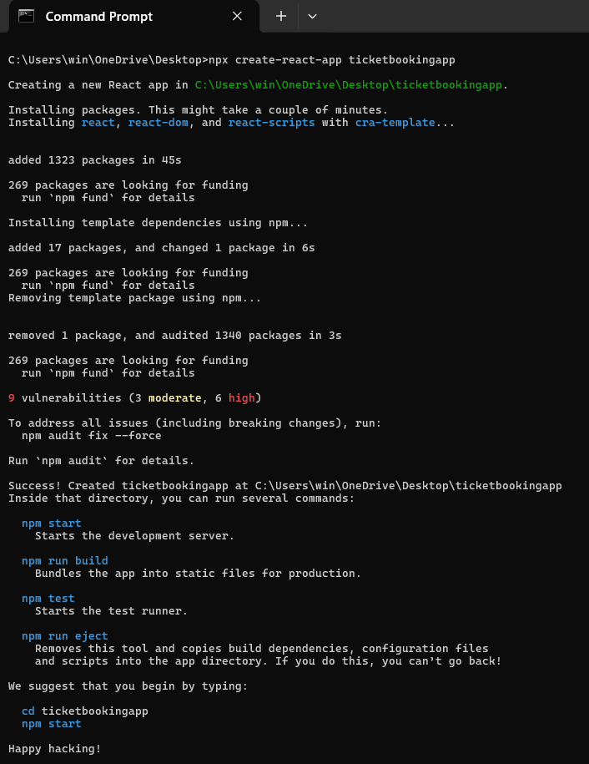
- Project Structure :
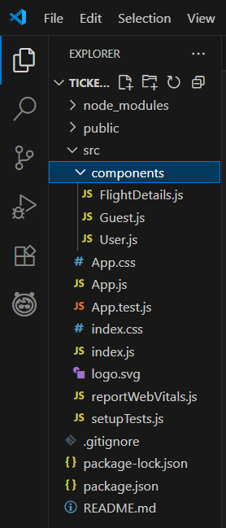
- Create Components :

Guest.js
import React from 'react';

function Guest({ onLogin }) {
return (
<div>
<h2>Welcome, Guest!</h2>
<p>You can browse flight details but booking is disabled.</p>
<button onClick={onLogin}>Login</button>
</div>
);
}

export default Guest;

User.js
import React from 'react';

function User({ onLogout }) {
return (
<div>
<h2>Welcome, User!</h2>
<p>You can now book flights!</p>
<button onClick={onLogout}>Logout</button>
</div>
);
}

export default User;

FlightDetails.js
import React from 'react';

function FlightDetails() {
return (
<div>
<h3>Flight Details</h3>
<ul>
<li>Flight A - 10:00 AM</li>
<li>Flight B - 12:00 PM</li>
<li>Flight C - 3:00 PM</li>
</ul>
</div>
);
}

export default FlightDetails;

- Update App.js with Conditional Rendering:
import React, { useState } from 'react';
import Guest from './components/Guest';
import User from './components/User';
import FlightDetails from './components/FlightDetails';

function App() {
const [isLoggedIn, setIsLoggedIn] = useState(false);

const handleLogin = () => setIsLoggedIn(true);
const handleLogout = () => setIsLoggedIn(false);

return (
<div>
<h1>Ticket Booking App</h1>
<FlightDetails />
{isLoggedIn ? (
<User onLogout={handleLogout} />
) : (
<Guest onLogin={handleLogin} />
)}
</div>
);
}

export default App;

- Output :
